## Task

Create a user to order a pet using [Pet Management](https://petstore.swagger.io/#/pet), [Store Management](https://petstore.swagger.io/#/store), and [User Management](https://petstore.swagger.io/#/user) APIs.

## Task Workflow

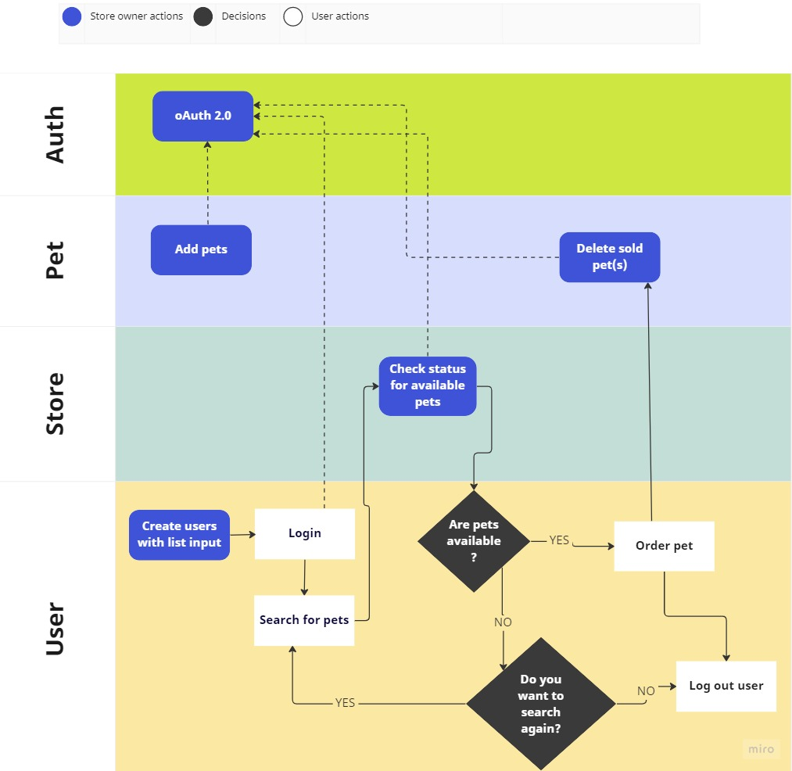

### Step 1:

(Optional) [Add pets](https://petstore.swagger.io/#/pet/addPet) to the inventory using Pet Management API. This requires authentication.

### Step 2:

(Optional) [Create a list of users](https://petstore.swagger.io/#/user/createUsersWithListInput) with the given input array. This can be done either through a list or an array.

### Step 3:

[Login a user](https://petstore.swagger.io/#/user/loginUser) through their username and password. This requires authentication to authorize the user login.

### Step 4:

As the user search for pets, display the list of **available** pets using the [**findBystatus**](https://petstore.swagger.io/#/pet/findPetsByStatus) to filter the available pets. This requires authentication.

### Step 5:

If the desired pet is available, the user might [order the pet](https://petstore.swagger.io/#/store/placeOrder).

### Step 6:

If the desired pet is unavailable in the inventory, the user can either choose to go back to step 4 or step 8.

### Step 7:

[Delete the ordered pet](https://petstore.swagger.io/#/pet/deletePet) from the inventory. This requires authentication.

### Step 8:

[Log out](https://petstore.swagger.io/#/user/logoutUser) the current user.

### Authentication

Authenticate using oAuth2. The following are the scopes available to grant access to the application on behalf of the user:

|  |  |
| --- | --- |
| Scope Name | Description |
| read:pets | read your pets |
| write:pets | modify pets in your account |

To obtain the user's consent, you must redirect the user to the authorization page and pass the scopes for which you need permission to access.

|  |
| --- |
| petstore_auth (OAuth2, implicit)  Authorization URL: <https://petstore.swagger.io/oauth/authorize>  Flow: implicit  client_id: 123xxxx |

Once the user responds to the consent request, the OAuth 2.0 server redirects the user with an **api_key** which can be used to authorize any further endpoint calls.

## [Reference](https://petstore.swagger.io/)